4.34 Using Fig. 4.102, design a problem that will help other students better understand Thevenin equivalent circuits.

Although there are many ways to work this problem, this is an example based on the same kind of problem asked in the third edition.

Problem

Find the Thevenin equivalent at terminals a-b of the circuit in Fig. 4.102.

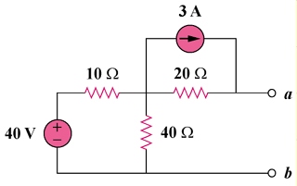

Figure 4.102

Solution

To find R_{Th}, consider the circuit in Fig. (a).

(a)
10 Ω
40 Ω
20 Ω
R_{Th}
40V

+
−

v₁
3 A
10 Ω
40 Ω
20 Ω
V_{Th}
+
v₂
(b)

R_{Th} = 20 + 10||40 = 20 + 400/50 = 28 ohms

To find V_{Th}, consider the circuit in Fig. (b).

At node 1, (40 – v₁)/10 = 3 + [(v₁ – v₂)/20] + v₁/40, 40 = 7v₁ – 2v₂ (1)

At node 2, 3 + (v1- v2)/20 = 0, or v1 = v2 – 60 (2)

Solving (1) and (2), v₁ = 32 V, v₂ = 92 V, and V_{Th} = v₂ = 92 V

